X  
  
  
  
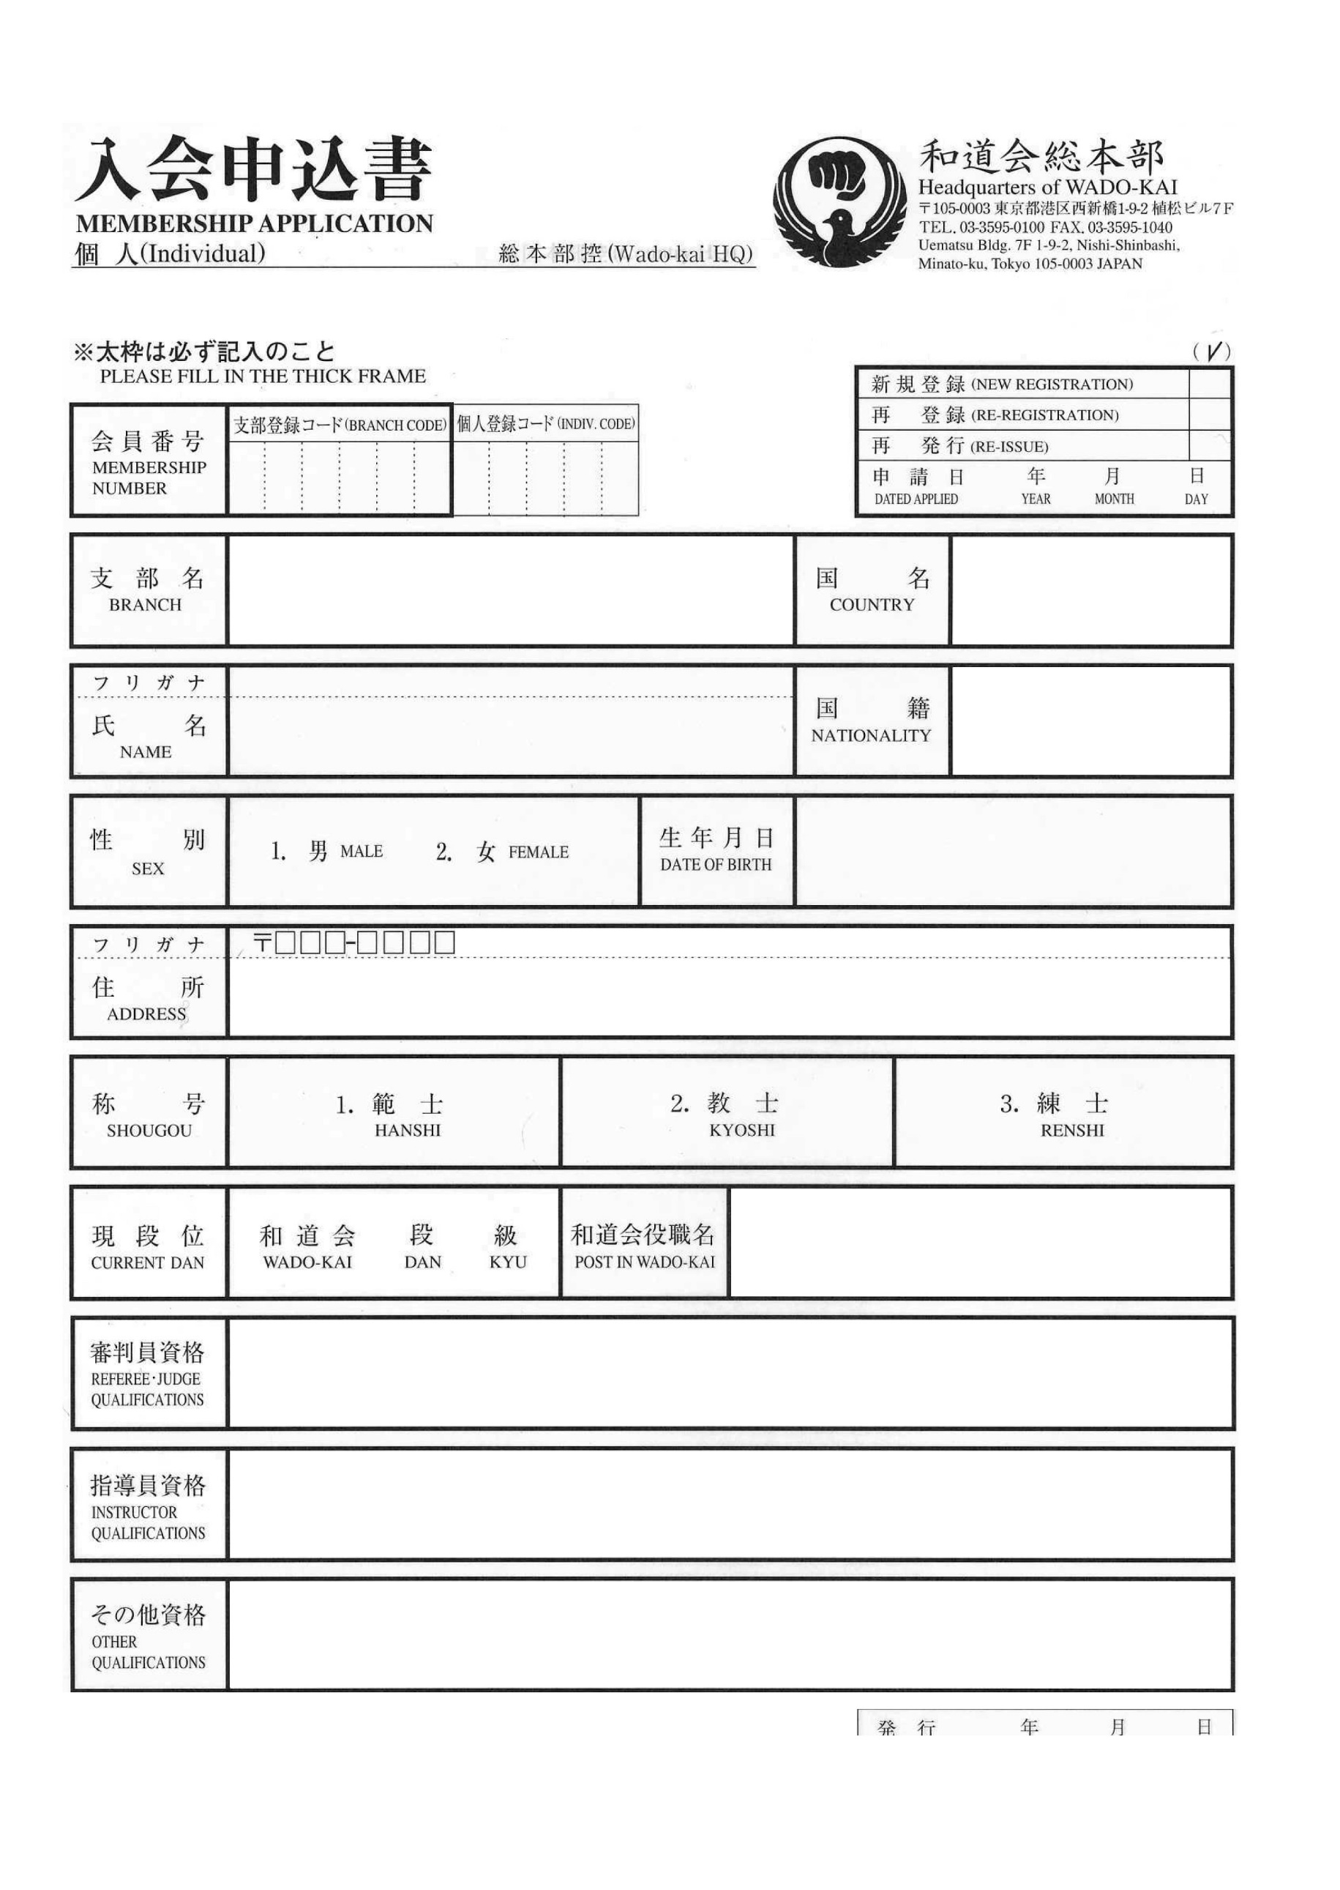**4 2 7 0 0 4** vvvv kk pp

Tapanilan Era Finland

Finnish

Male / Female vvvv-kk-pp